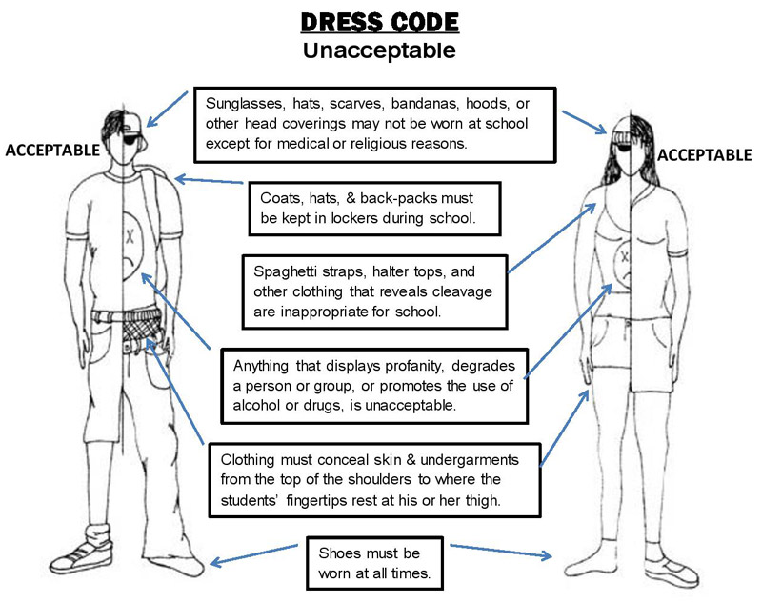

**Sleeveless apparel must be 3 fingertip lengths wide to be appropriate for school. Spaghetti straps, t-shirts with cut out arms and halter tops are not permitted.**

**Sunglasses, hats, bandanas, hoods and other head coverings may not be worn at school unless it is permitted for SHMS Spirit Day, medical or religious reasons. Spirit Day will be announced and both students and parents will be notified.**

**LEGGINGS/JEGGINGS should be worn with a shirt that is fingertip length that covers the buttocks.**

**Students may wear heavy jackets to school if they choose; however, heavy coats and jackets and/or oversized jackets (hoodies) must be placed in student lockers while at school.**

**Anything that displays profanity, degrades a person or groups, promotes violence or the use of alcohol or drugs, is unacceptable. Clothing/hats/shoes should not distract from learning.**

**Clothing must conceal skin and undergarments from the top of the shoulders to where the students’ fingertips rest at his/her thigh. This include skin revealed by holes in jeans. Cleavage and sagging pants are inappropriate.**

**Consequences**

**-Student with inappropriate attire are sent to the office**

**-Student contacts parent to bring appropriate attire**

**-Student reports to ISS until parent arrives**

**-Students who refuse to comply will be subject to further disciplinary action**

**SHMS Dress Code**